**Experiment 2**   
By Kushagra Agarwal  
500125138  
Batch 1 IOT  
<https://github.com/Kushonwork>

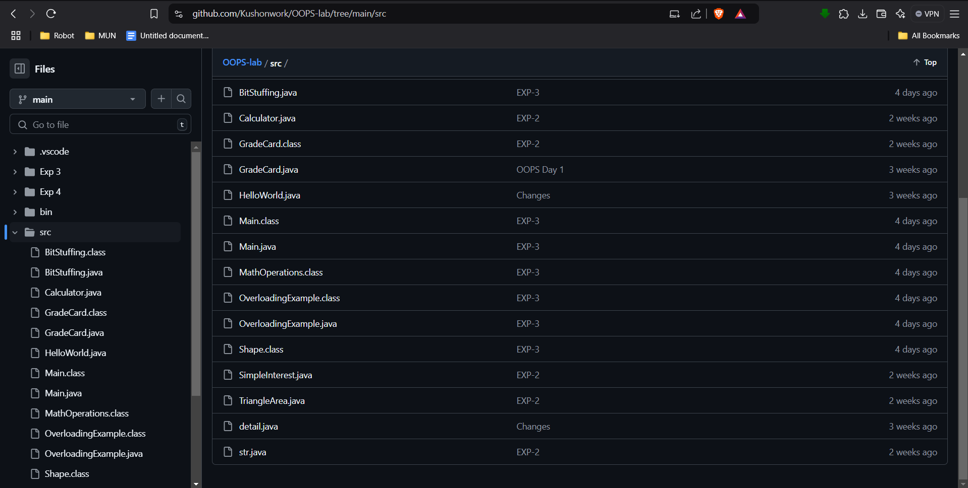

1. Program to Find Area of Triangle

public class TriangleArea {

public static void main(String[] args) {

if (args.length < 2) {

System.out.println("Please provide base and height of the triangle.");

return;

}

double base = Double.parseDouble(args[0]);

double height = Double.parseDouble(args[1]);

double area = 0.5 * base * height;

System.out.println("Area of the triangle is: " + area);

}

}

2. Program to Find Simple Interest

public class SimpleInterest {

public static void main(String[] args) {

if (args.length < 3) {

System.out.println("Please provide principal, rate and time.");

return;

}

double principal = Double.parseDouble(args[0]);

double rate = Double.parseDouble(args[1]);

double time = Double.parseDouble(args[2]);

double interest = (principal * rate * time) / 100;

System.out.println("Simple Interest is: " + interest);

}

}

3. Command Line Calculator

public class Calculator {

public static void main(String[] args) {

if (args.length != 3) {

System.out.println("Please provide two numbers and an operator.");

return;

}

int num1 = Integer.parseInt(args[0]);

String operator = args[1];

int num2 = Integer.parseInt(args[2]);

int result;

switch (operator) {

case "+":

result = num1 + num2;

System.out.println("Sum of " + num1 + " and " + num2 + " is " + result);

break;

case "-":

result = num1 - num2;

System.out.println("Difference of " + num1 + " and " + num2 + " is " + result);

break;

case "*":

result = num1 * num2;

System.out.println("Product of " + num1 + " and " + num2 + " is " + result);

break;

default:

System.out.println("Invalid operator. Please use +, -, or *.");

}

}

}

4. Check if the Number is Positive, Negative, or Zero

```java

public class NumberCheck {

public static void main(String[] args) {

if (args.length < 1) {

System.out.println("Please provide a number.");

return;

}

int number = Integer.parseInt(args[0]);

if (number > 0) {

System.out.println("The number is positive.");

} else if (number < 0) {

System.out.println("The number is negative.");

} else {

System.out.println("The number is zero.");

}

}

}

5. Find the Greatest Among Three Integers

public class GreatestOfThree {

public static void main(String[] args) {

if (args.length < 3) {

System.out.println("Please provide three integers.");

return;

}

int a = Integer.parseInt(args[0]);

int b = Integer.parseInt(args[1]);

int c = Integer.parseInt(args[2]);

int greatest;

if (a >= b) {

if (a >= c) {

greatest = a;

} else {

greatest = c;

}

} else {

if (b >= c) {

greatest = b;

} else {

greatest = c;

}

}

System.out.println("The greatest number is: " + greatest);

}

}

6. Display Day of the Week Based on Number

public class DayOfWeek {

public static void main(String[] args) {

if (args.length < 1) {

System.out.println("Please provide a number (1-7).");

return;

}

int day = Integer.parseInt(args[0]);

String dayName;

switch (day) {

case 1:

dayName = "Sunday";

break;

case 2:

dayName = "Monday";

break;

case 3:

dayName = "Tuesday";

break;

case 4:

dayName = "Wednesday";

break;

case 5:

dayName = "Thursday";

break;

case 6:

dayName = "Friday";

break;

case 7:

dayName = "Saturday";

break;

default:

dayName = "Invalid input. Please enter a number between 1 and 7.";

}

System.out.println("Day of the week is: " + dayName);

}

}